Mercury
Venus
Earth
Mars

ROCKY PLANETS
Sun

Sidewalk Astronomers

Jupiter
GAS GIANTS

Neptune

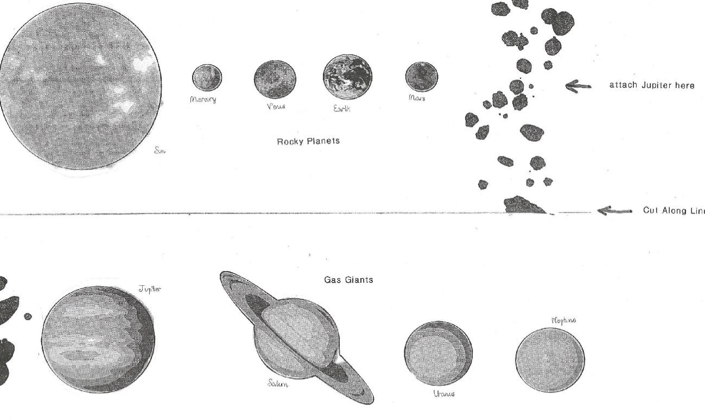Saturn Sidewalk Astronomers

Uranus

